Section I: Scenario Demographics

Scenario Title: | Obstetrical Trauma
Date of Development: | 26/04/2016 (DD/MM/YYYY)
Target Learning Group: | Juniors (PGY 1 – 2) Seniors (PGY ≥ 3) All Groups

Section II: Scenario Developers

Scenario Developer(s): | Donika Orlich
Affiliations/Institution(s): | McMaster University
Contact E-mail (optional): | Donika.orlich@medportal.ca

Section III: Curriculum Integration

Learning Goals & Objectives
Educational Goal: | Expose learners to trauma in the obstetrical patient
CRM Objectives: | - Leads by staying calm and in control during crisis and employing a prompt decision making process  - Communicates clearly, listens to team input, and uses verbal and nonverbal communication with family
Medical Objectives: | - Demonstrates a tailored approach to resuscitation in the pregnant trauma patient  - Determines fetal viability, initiates monitoring and considers need for steroids  - Recognizes the potential for a difficult airway and justifies choice for RSI medications

Case Summary: Brief Summary of Case Progression and Major Events
A 33 year old G1P2 female at 32 weeks GA presents with blunt trauma following an MVC. She will be hypotensive due to both hypovolemic shock from a pelvic fracture and obstructive shock from a tension pneumothorax. Fetal monitoring will show the fetus in distress with tachycardia and late decelerations. Early airway intervention should be employed, with thoughtful selection of drugs for sedation and paralysis given the pregnancy. After intubation, the patient will remain hypotensive. She will require massive transfusion and coordination of care between orthopedics, general surgery, and obstetrics. The patient’s husband will also arrive after intubation and the team must give him the bad news.

References
Marx, J. A., Hockberger, R. S., Walls, R. M., & Adams, J. (2013). Rosen's emergency medicine: Concepts and clinical practice. St. Louis: Mosby.
Collman, R. Somogyi, R. (2008) Toronto Notes 2008: comprehemsive medical reference. Type & Graphics Inc. Toronto, ON.

Section IV: Scenario Script

A. Scenario Cast & Realism
Patient: | Computerized Mannequin |  |  |  |  | Realism:  Select most important dimension(s) |  |  | Conceptual
 | Mannequin |  |  |  |  |  |  |  | Physical
 | Standardized Patient |  |  |  |  |  |  |  | Emotional/Experiential
 | Hybrid |  |  |  |  |  |  |  | Other:
 | Task Trainer |  |  |  |  |  |  |  | N/A
Confederates | Brief Description of Role
EMS | Provides handover. Repeats about decreased air entry on left if no chest tube by 5 mins
Father | Arrives after intubation. Distraught and must be given bad news.
Noise soundtrack | Either have multiple “consultants” arrive because “they heard about a pregnant trauma” or play background noise in room until team leader asks for calm and order.
B. Required Monitors
EKG Leads/Wires |  |  | Temperature Probe |  |  |  | Central Venous Line
NIBP Cuff |  |  | Defibrillator Pads |  |  |  | Capnography
Pulse Oximeter |  |  | Arterial Line |  |  |  | Other: Fetal HR monitor or Doppler U/S
C. Required Equipment
Gloves |  |  | Nasal Prongs |  |  |  | Scalpel
Stethoscope |  |  | Venturi Mask |  |  |  | Tube Thoracostomy Kit
Defibrillator |  |  | Non-Rebreather Mask |  |  |  | Pelvic tray/speculum
IV Bags/Lines |  |  | Bag Valve Mask |  |  |  | Thoracotomy Kit
IV Push Medications |  |  | Laryngoscope |  |  |  | Central Line Kit
PO Tabs |  |  | Video Assisted Laryngoscope |  |  |  | Arterial Line Kit
Blood Products |  |  | ET Tubes |  |  |  | Other: Fetal tocomoter
Intraosseous Set-up |  |  | LMA |  |  |  | Other: 14G angiocath
D. Moulage
Female wig and props to make mannequin appear pregnant. Blood/bruise on forehead. Superficial laceration left arm. Pelvis bound by EMS. C-collar in situ.

E. Approximate Timing
Set-Up: |  | 5min |  | Scenario: | 20 min |  |  | Debriefing: |  | 40 min

Section V: Patient Data and Baseline State

A. Clinical Vignette: To Read Aloud at Beginning of Case
You are working in a tertiary care emergency department and receive an EMS Patch: "33F who appears quite pregnant coming to you from an MVC. Belted driver. Prolonged extrication at the scene (30mins). Altered LOC and hypotensive on scene. Current vitals: HR 150, BP 80/50, RR 40, O2 90% on NRB, CBG 6. 1L NS bolus going. ETA 5 minutes."
B. Patient Profile and History
Patient Name: Melissa Porter |  |  |  |  |  | Age: 33 |  |  |  |  |  |  |  | Weight: 80kg
Gender: M F |  |  |  |  |  | Code Status: Full
Chief Complaint: MVC
History of Presenting Illness: Sole occupant belted driver MVC at approximately 100km/h on highway. Significant damage to car, with prolonged extraction. Obviously pregnant. Decreasing GCS (14 ->9) en route (initially confused but answering questions, now only moaning)
Past Medical History: |  | G1P0- 32 weeks |  |  |  |  | Medications: |  |  |  |  | Prenatal vitamins
 |  | No complications in current pregnancy
Allergies: None
Social History: Husband (she was calling for him, but EMS could get no other information)
Family History: unknown
Review of Systems: |  | CNS: |  |  | Patient unable to answer questions
 |  | HEENT: |  |  | Patient unable to answer questions
 |  | CVS: |  |  | Patient unable to answer questions
 |  | RESP: |  |  | EMS note decreased air entry to left side
 |  | GI: |  |  | Patient unable to answer questions
 |  | GU: |  |  | EMS palpated uterus above umbilicus. Pt cc contractions before
 |  | MSK: |  |  | EMS note lac to L arm |  |  |  |  |  |  |  | INT:
C. Baseline Simulator State and Physical Exam
No Monitor Display |  |  |  | Monitor On, no data displayed |  |  |  |  |  |  | Monitor on Standard Display
HR: 155/min |  |  | BP: 80/50 |  |  |  |  | RR: 40/min |  |  |  |  |  |  | O₂SAT: 90% NRB
Rhythm: sinus |  |  | T: 35.5ºC |  |  |  |  | Glucose: 6 mmol/L |  |  |  |  |  |  | GCS: 9 (E2 V2 M5)
General Status: Patient moaning. Blood on arm and face.
CNS: | Eyes open to pain, Incomprehensible sounds, Localize to pain
HEENT: | PEERL 4mm bilaterally. Bruise and dried blood over forehead. C-collar with EMS
CVS: | Normal S1, S2. No murmurs.
RESP: | Decreased air entry on left with overlying crepitus. Tracheal tug to right.
ABDO: | Distended. Bruising over flanks. Moans to palpation.
GU: | No obvious vaginal bleeding. Uterus 10cm above umbilicus. Palpable contractions.
MSK: | Superficial lac left forearm. Pelvis unstable and bound by EMS |  |  |  |  |  |  |  | SKIN: | Cool

Section VI: Scenario Progression

Scenario States, Modifiers and Triggers
Patient State | Patient Status | Learner Actions, Modifiers & Triggers to Move to Next State
1. Baseline State  Rhythm: sinus  HR: 150/min  BP: 80/50  RR: 40/min  O₂SAT: 90% NRB  T: 35.5ºC  Fetal Monitoring  HR: 170/min  Variability: decreased  Decelerations: late (contractions q5min) | GSC 9. Moaning. Cool extremities. | Learner Actions  - IV, O2, monitors  - Capillary sugar (6.0)  - Continuous Fetal monitors  - Manual uterine displacement to left or tilt patient with wedge under right  - Labs (BhCG, DIC screen, Kleihauer-Bletke test, Rh status, Group & Screen)  - A: airway assessment  - B: needle decompression and chest tube on left  - C: 2u O- pRBC, IV NS bolus until arrives  - D: elevate head of bed  - Secondary survey for uterine contractions  - PV exam to r/o vaginal bleeding  - FAST US exam (+FF)  - Chest & Pelvis x-ray  - TxA 1g IV over 10 mins  - Activate massive transfusion protocol  - Obstetrics consult  - Call for NICU  - Surgery and ortho consult  - Call for neonatal warmer & resus equipment, delivery tray | Modifiers  Changes to patient condition based on learner action  - Needle decompression gush of air back, O₂ 95%, BP same  - Chest tube 200cc blood, O₂ 97%, BP 85/55, RR 20  - NS/blood transfusion BP unchanged  - No chest tube/decompression by 5 minutes EMS states “what about the air entry on the left?”  Triggers  For progression to next state  - All learner actions complete or 8 minutes -> 2. Persistent hypotension
2. Persistent Hypotension  Rhythm: sinus  HR: 155/min  BP: 75/45  RR: 20/min  O₂SAT: 95% NRB  Fetal Monitoring  HR: 175 | Patient cool, mottled skin.  Now no eye opening to pain, no verbal response (GCS 6) | Learner Actions  - Level 1 transfuser for 1:1:1 transfusion strategy  - TxA if not given  - Celestone 12mg IM x1  - RA pupils/neuro status  - Consider cordis insertion  - Consider arterial line  - Plan for intubation | Modifiers  - Level 1 transfusion  BP 85/60, HR 140  - Transfuse without level 1 BP/HR unchanged  - No intubation by 10 min O₂ slowly drops to 86%  Triggers  - Plan for intubation  3. Intubation
3. Intubation  Rhythm: sinus  HR: 140/min  BP: 85/60  RR: 20/min  O₂SAT: 94% NRB  Fetal Monitoring  HR: 180 | As above.  Abdomen more distended. | Learner Actions  - Call for difficult airway cart  - Use blood-pressure stable agents for RSI (eg – ketamine)  - Plan for neuroprotective RSI (fentanyl, rocuronium)  - Push-dose phenyl on hand | Modifiers  - Sedation/paralytic given O2 decreases to 85% over 1min  - Propofol used BP 60/40, HR 150  Triggers  - Intubation complete  4. Husband Arrives
4. Husband Arrives  Rhythm: sinus  HR: 140/min  BP: 60/40  RR: 12/min vented  O₂SAT: 99% vented  Fetal Monitoring:  HR: 190 |  | Learner Actions  - Post-intubation sedation  - Post-intubation CXR  - Deliver bad news to father  - Continue 1:1:1 transfusion  - Call OB again  - Call General Surgery and ortho again (likely needs joint OR) | Modifiers  Triggers  - Situation disclosed to father END CASE PRN

Section VII: Supporting Documents, Laboratory Results, & Multimedia

Laboratory Results
Not available

Images (ECGs, CXRs, etc.)
CXR: Left tension pneumothorax
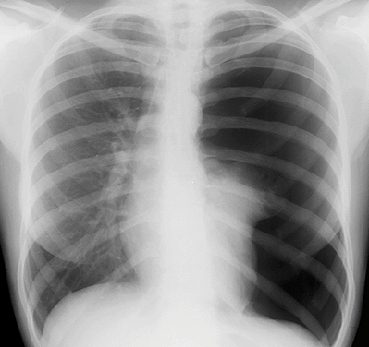
(CXR source: http://cdem.phpwebhosting.com/ssm/pulm/pneumothorax/images/cxr_ptx_3.png)
Pelvis X-Ray: open book pelvic # with binder  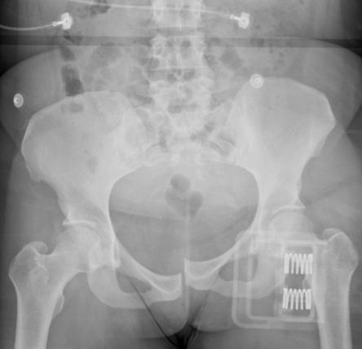  (XR source: https://drhem.files.wordpress.com/2011/11/5-4-6.jpg) |  | ECG: sinus tachycardia  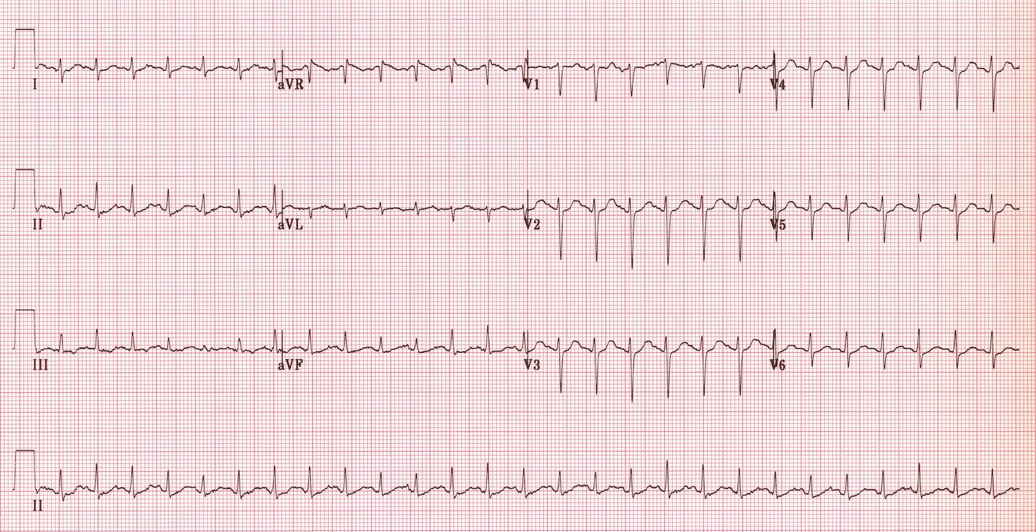  (ECG source: http://i0.wp.com/lifeinthefastlane.com/wp-content/uploads/2011/12/sinus-tachycardia.jpg)
Ultrasound Video Files (if applicable)
Pericardium: no PCE | Lung: Left pneumothorax/hemothorax
Abdomen: + FF | Uterus: + Fetal heart activity

Section VIII: Debriefing Guide

General Debriefing Plan
Individual | Group |  | With Video | Without Video
Objectives
Educational Goal: |  | Expose learners to trauma in the obstetrical patient
CRM Objectives: |  | - Demonstrates leadership staying calm and in control during crisis and employing a prompt decision making process  - Demonstrates strong communication skills communicating clearly and listening to team input, and using verbal and nonverbal communication with family
Medical Objectives: |  | - Demonstrates a tailored approach to resuscitation in the pregnant trauma patient  - Determines fetal viability, initiates monitoring and considers need for steroids  - Recognizes the potential for a difficult airway and justifies choice for RSI medications
Sample Questions for Debriefing
- What unique physical exam, monitoring and lab investigations are needed in the pregnant trauma patient? What was your approach to incorporating these into the primary/secondary surveys?
- What features on fetal monitoring are concerning? Are you aware of any medical interventions that should be directed at the fetus?
- What was your approach to intubation in this patient? Why did you choose the drugs you did?
- When should a perimortem C-section be considered? What are the steps to this procedure?
- What was your approach to breaking bad news to the father? Are you aware of any frameworks that might help you in this situation?
Key Moments
- Recognition of tension PTX
- Tailors approach to trauma resuscitation in the pregnant patient (uterine displacement, secondary GU survey)
- Anticipates a difficult airway and employs a tailored approach to RSI medication selection
- Maintaining control of chaotic trauma environment with multiple providers
- Breaking bad news

